**ASSIGNMENTS ON DIGITAL MARKETING**

**Name: DHAYANIDHI S**

**DEPARTMENT: COMPUTER SCIENCE AND ENGINEERING**

**COURSE DETAIL: DIGITAL MARKETING**

**COLLEGE: DHANALAKSHMI SRINIVASAN INSTITUTE OF TECHNOLOGY**

**NM ID: 3A451D35F5020CD8C1E4B2E2C4C8F39C**

**ZONE: 12**

**ASSIGNMENT 1:**

Create a blog or website using Blogspotand WordPress. Customize

The theme design and post new article with 500 words <https://rockybikersclub78.blogspot.com/2023/08/sales-discover-ultimate-destination-for.html>

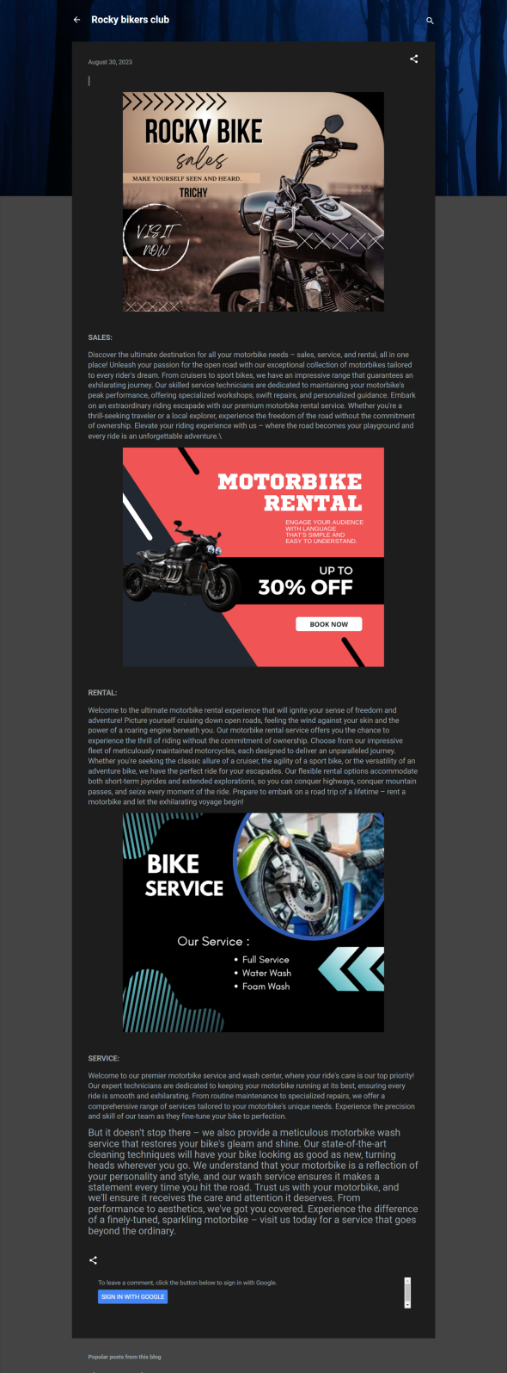

**ASSIGNMENT 2:**

Create a new Facebook business Page and Post one social media poster for your brand. <https://www.facebook.com/profile.php?id=61550338182422>

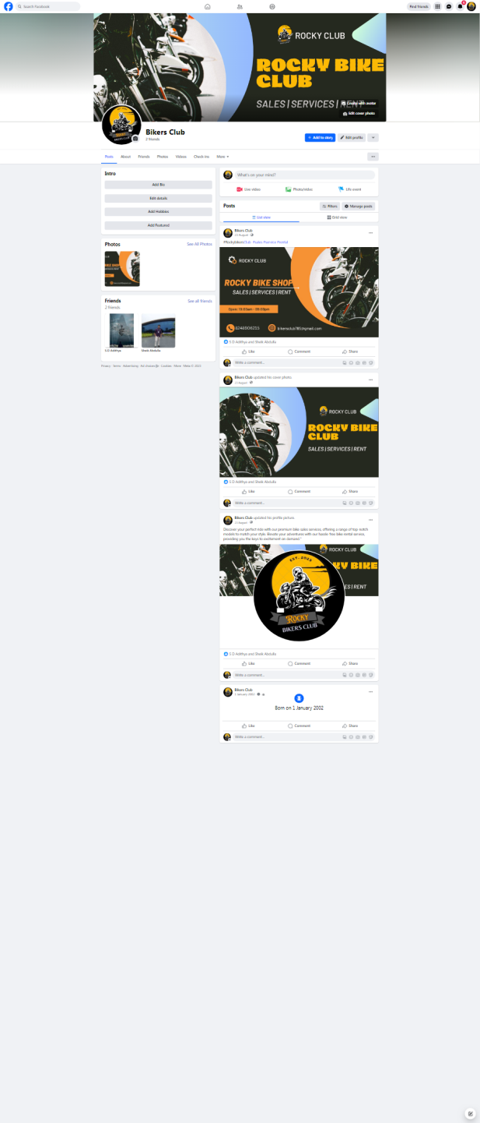

**ASSIGNMENT 3:**

Create and design a social media advertisement poster using Canva.

<https://rockybikersclub78.blogspot.com/2023/08/about-motorcycle.html>

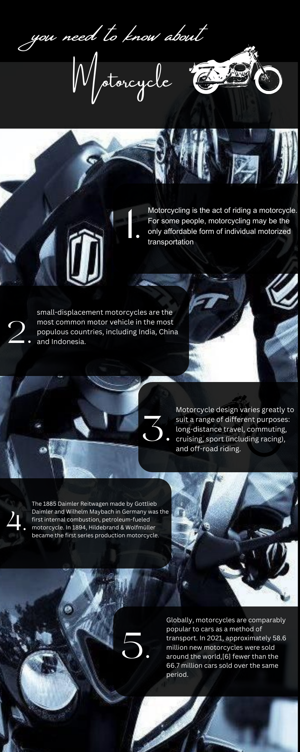

**ASSIGNMENT 4:**

4.Create email newsletter design using MailChimp or Canva tool <https://rockybikersclub78.blogspot.com/2023/08/blog-post.html>.

